**E**stimation **A**nd **C**onfidence **I**ntervals

**Background**

In quality control processes, especially when dealing with high-value items, destructive sampling is a necessary but costly method to ensure product quality. The test to determine whether an item meets the quality standards destroys the item, leading to the requirement of small sample sizes due to cost constraints.

**Scenario**

A manufacturer of print-heads for personal computers is interested in estimating the mean durability of their print-heads in terms of the number of characters printed before failure. To assess this, the manufacturer conducts a study on a small sample of print-heads due to the destructive nature of the testing process.

**Data**

A total of 15 print-heads were randomly selected and tested until failure. The durability of each print-head (in millions of characters) was recorded as follows:

1.13, 1.55, 1.43, 0.92, 1.25, 1.36, 1.32, 0.85, 1.07, 1.48, 1.20, 1.33, 1.18, 1.22, 1.29

**Assignment Tasks**

**a. Build 99% Confidence Interval Using Sample Standard Deviation**

Assuming the sample is representative of the population, construct a 99% confidence interval for the mean number of characters printed before the print-head fails using the sample standard deviation. Explain the steps you take and the rationale behind using the t-distribution for this task.

**b. Build 99% Confidence Interval Using Known Population Standard Deviation**

If it were known that the population standard deviation is 0.2 million characters, construct a 99% confidence interval for the mean number of characters printed before failure.

Ans: To construct confidence intervals for the mean number of characters printed before the print-head fails, we can follow these steps:

1. Build 99% Confidence Interval Using Sample Standard Deviation:
2. Calculate the sample mean  and sample standard deviation (s) from the given data.

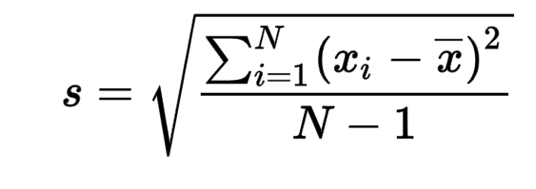

1. Determine the sample size (n).
2. Find the critical value (t*) from the t-distribution table for a 99% confidence level and (n-1) degrees of freedom.
3. Calculate the margin of error (E) using the formula: .
4. Construct the confidence interval using the formula:).
5. Explain the rationale behind using the t-distribution: Since the population standard deviation is unknown, and the sample size is small (n < 30), we use the t-distribution instead of the normal distribution to account for the uncertainty in estimating the population standard deviation from the sample standard deviation.
6. Build 99% Confidence Interval Using Known Population Standard Deviation:
7. Calculate the sample mean (xˉ) from the given data.
8. Determine the sample size (n).
9. Find the critical value (z*) from the standard normal distribution table for a 99% confidence level.
10. Calculate the margin of error (E) using the formula:  , where σ is the known population standard deviation.
11. Construct the confidence interval using the formula: 